The comparison between machine learning strategies and mathematical strategies for a trading bot on the cryptocurrency market

Reece Cripps, MSc

Submitted to The School of Computer Science, University of Nottingham  
in September 2022  
in partial fulfilment of the conditions for the award of the degree of   
Master of Science in Computer Science with Artificial Intelligence

**09/08/2022**

# Contents

2

Contents 3

Abstract 4

Acknowledgements 5

Introduction 6

1.1 Project Aims 6

1.2 Requirements/Objectives 6

1.3 Background into the Cryptocurrency 8

Literature Review 9

2.1 Technologies and Libraries 9

2.2 Research papers 10

2.3 Existing Trading Bots 19

Design and Implementation 21

3.1 Software Design 21

3.2 Mathematical Strategies 21

3.3 Machine Learning Strategies 21

Results and Discussion 22

4.1 Mathematical Results 22

4.2 Machine Learning Results 22

4.3 Combined Evaluation 22

4.4 Did I meet my Aims/Objectives? 22

Critical Appraisal 23

5.1 What went well 23

5.2 What went badly 23

5.3 What I would have done differently 23

5.4 Future Development 23

Conclusion 24

References 25

Appendix A: Supplementary Materials I 25

# Abstract

Cryptocurrency has taken off during the past couple of years, with popularity soaring throughout the globe. The amount of money flowing into cryptocurrency reached $3 Trillion making it one of the biggest industries in the world. The stock market has been around for a long time and there are a lot of tools out there that businesses use to maximise their returns. However, with cryptocurrency being new and volatile the tools available are scarce or not as accurate as they could be. In this project I have researched a variety of different methods to compare and evaluate the most accurate method at trading and predicting the price of the top crypto assets. With this project being a regression problem, the accuracy of the models can vary. Some machine learning methods have not been considered as they’re not necessarily known for their effectiveness at solving regression problems. I have also taken some of the most popular mathematical indicators when it comes to trading and implemented these as a comparison to the machine learning methods.

# Acknowledgements

I would like to thank my supervisor Colin Johnson for being very supportive along the journey through completing this project. I would also like to thank my friends and family for helping me through the tough times and keeping me motivated throughout.

# Introduction

## Project Aims

The **Main Aim** of my project is to explore different strategies and apply them to the cryptocurrency market. This tool will be useful for researchers and academics because they can see a breakdown of a variety of different methods, both mathematical and machine learning. There is also a clear comparison between these methods, to see which is the best overall.

The different trading bots will be tested on multiple scenarios:

* Past – 2018-2021
* Present – 2021-2022
* Real-time – Current time of testing (July/August 2022).

For these scenarios they have been tested on multiple different coins as well. I have tested the top 2 coins (Bitcoin and Ethereum) as well as some less popular coins, Loopring and Litecoin. These coins are still in the top 50 crypto coins because venturing further away from the popular coins induces more volatility which becomes extremely difficult to predict.

For each trading bot, users are able to see the breakdown of the data in graph form and also able to switch to text format. The bots can then trade at their own pace, buying and selling positions.

Data is then exported to an excel file where it can be analysed and compared. This will be a lot easier than looking at the graph and text output displayed by the program.

## Requirements/Objectives

Looking at the project aims, there are a number of different requirements and objectives that needs to be fulfilled.

**Simple and effective UI:**

For this project I aim for the UI to be simple but effective. This means that any users that wish to utilise my program will find it easy to use and not too confusing. For example, I do not want to bombard users with constant text printing out to the user but instead represent a graph format with an option to switch to text view. The text view will then be colour coded so users can easily distinguish between sell and buy orders. The main page of the program will also have a menu which contains all the bots so that users can click on the bot they wish to use.

**Mathematical trading strategies:**

There are a lot of mathematical strategies available to test and use. I wanted to take some of the most well-known strategies and compare them to machine learning strategies. So, for this, I used a number of different recommendations to pick out the best strategies to use [1]. The moving average strategy and Relative strength index strategy provide good indicators as to how the market is moving. A more in-depth explanation can be found in the implementation section (3.2 – Mathematical strategies).

**Machine Learning strategies:**

Machine learning is becoming more popular and the technology available makes creating machine learning programs more accessible to the average person. Creating machine learning strategies could be better than traditional mathematical strategies because of the computing power available. For this project I intend to use 2 Machine learning strategies: Support Vector Machines and Artificial Neural Networks. If time permits, I will also be creating a regression tree. How these strategies work will be explained in the implementation section (3.3 – Machine learning strategies).

**Multiple trading scenarios:**

In the current market environment, I think that it would be an unfair representation of the trading strategies. To grasp a better understanding of the methods, implementing multiple trading scenarios will help me understand how these strategies work and what scenarios they excel in.

For this project I have chosen to look at data from 2018-2021. This is because 2018 was when the popularity for cryptocurrency took off [Fig 1]. For the Machine learning strategies training data will be 2018 – 2020 and then test data will be 2021. For the mathematical strategies, they will just be tested on 2021 data.

The second trading scenario will be 2021-2022 where the machine learning bots will be trained on 2021 data and then tested on 2022 (Jan – July). The mathematical strategies will be tested on 2022 (Jan – July)

Finally, the trading bots will be tested in real-time to see how they perform. For this the machine learning strategies will be trained on 2022- Jan – July data (at 4 hour intervals) and then tested in real-time (1 day before current time – current time and left running for 2 days).

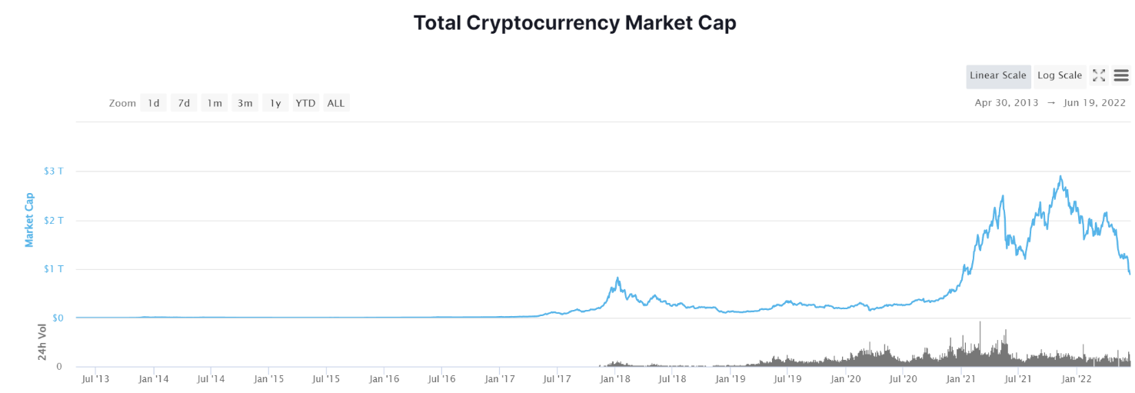

Figure 1 – Cryptocurrency Market Capacity

Source: <https://coinmarketcap.com/charts/>

**Variety of crypto coins:**

For this project, I intend to test multiple different coins. This is because the prices of the different coins depend on multiple factors so getting a larger range of coin data will allow for a more even spread and a fairer result of the strategies. However, there is a common pattern between Bitcoin and the rest of the coins. If bitcoin is on a downtrend then other coins will mostly follow (see 1.3 – Background into the crypto Market).

**Data analysis:**

To be able to see which trading bots perform well, exporting all the data to an excel file will allow for better readability. I can also create graphs and formulae to allow for a more in-depth analysis of the data and results.

## Background into Cryptocurrency

Bitcoin started in 2008/2009 as the first blockchain network, created by Satoshi Nakamoto [3]. To collect Bitcoin, you had to mine it with a complicated algorithm. it first became tradable back in 2009/2010 being worth less than $0.14. The first physical transaction with Bitcoin was made in May 2010 where 2 pizzas were purchased using 10,000 Bitcoin. At Bitcoin’s all time high that would be worth roughly $680 Million.

In 2013/2014 the popularity of cryptocurrencies grew. More and more coins were being developed and Bitcoin grew. [Fig 2] shows the dominance of Bitcoin in the market. Back in 2013 Bitcoin held ~94% of the market. Where as today, Bitcoin only accounts for 43%. Whilst this is still a huge portion of the market, things have changed drastically over the years.

Figure 2 – Bitcoin dominance

Source: <https://coinmarketcap.com/charts/>

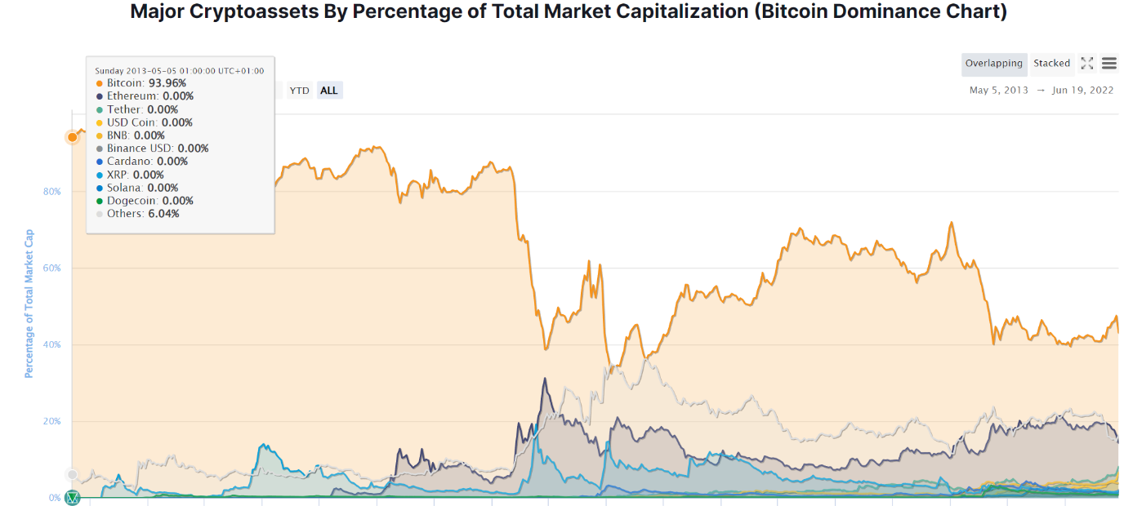

This dominance means that Bitcoin tends to control the market prices. If Bitcoin is on a downward trend then the other coins will likely follow [4]. Another reason for Bitcoin’s impact to other coins is that other coins can’t normally be purchased or sold with fiat currency (like USD or GBP) instead, these coins have to first be traded to and from Bitcoin and then into their fiat currency meaning that Bitcoin acts as a middleman in these transactions making it more important.

Looking at [Fig 1] You can see how the global market compares today. At the back end of 2021, the total amount of money in crypto currency was around $3 Trillion which is vastly bigger than 2013’s $94 Million. Looking at the market today, it is in a downward trend and the majority of coin prices are falling. This means that the strategies that I’m using might not be very effective when testing the real-time trading. Therefore, I am using these strategies on a variety of scenarios to collect multiple data points and allow for a fairer analysis of the strategies.

# Literature Review



## Technologies and Libraries

In this section I will describe the background research done to find relevant libraries and technologies that I have used within my project.

### [Market](https://binance-docs.github.io/apidocs/spot/en/" \l "change-log) data API

The CoinAPI.io is an efficient and effective API that includes all of the endpoints that I will be needing for implementation [5]. Most other APIs available are either paid for or don’t offer enough depth in their historical data.

The endpoint that I will be using the most is:

GET v1/ohlcv/{symbol_id}/history?period_id={period_id}&time_start={time_start}&time_end={time_end}&limit={limit}

This endpoint allows ohlcv (open, high, low, close and volume) data to be collected with a symbol_id (crypto coin) and the period for the data points (1 day, 1 month, 1 year…) as well as the start and end time for the data points.

For example, 'https://rest.coinapi.io/v1/ohlcv/COINBASE _SPOT_BTC_USD/history?period_id=1DAY&time_start=2018-01-01T00:00:00&time_end=2020-12-31T00:00:00&limit=2000'

Will allow me to collect data on a daily basis between 2018 to 2020 for the value of bitcoin to USD on the coinbase market.

### Pandas/numpy/ Xlsxwriter

Pandas and Numpy are libraries useful for data processing in python. These two libraries work hand in hand for manipulation of data. I have used these libraries to compress the data collected from the API endpoints.

Xlsxwriter allows the use of writing data from python to an excel file. For my project I have taken all the data from each bot and written this to an excel file to allow better analysis of the data rather than looking at command line prints.

Xlsxwriter also works well with the pandas library so coupling these together is beneficial for data analysis.

### TensorFlow/SciKit

TensorFlow allows a simple creation of a neural network. For my project the neural network will be used to predict prices of the crypto coins. An in depth description of how this works can be found in 3.3 – Machine Learning strategies.

SciKit allows the creation of the support vector machine model. This will be used as my second machine learning strategy. More about how this works can be found in 3.3 – Machine Learning Strategies.

### MatplotLib

To display the market data MatplotLib will be used as a visually appealing way to display data to the users.

## Research papers

2.2.1 and 2.2.2 are my own work cited from [7].

### Crypto Price prediction using SVMs

Nor Azizah Hitam, Amelia Ritahani Ismail, and Faisal Saeed used an optimised support vector machine (SVM) based on particle swarm optimisation (PSO) to predict the price of cryptocurrencies [8].

Not only did they use Optimised SVM-PSO, but they also used a variety of other machine learning concepts as a comparison to their model. They used these models to test their predictive accuracy of 6 cryptos (Bitcoin, Ethereum, Litecoin, Nem, Ripple and Stellar).

The researchers designed a new algorithm to test their method against all other existing methods. They used a collection of daily price charts for 5 years from 2013 to 2018. For each classifier they had a training set from 2013 to 2017 and then tested the models on the data from 2017 to 2018.

They used quantitative methods to obtain results that are relevant to the paper. In this scenario, quantitative methods are far more appropriate because they needed to test how good their new method is at predicting prices. Qualitative methods would not have been able to provide mathematical evidence to prove their theory.

To back up their work they tested the accuracy of their model at predicting 364 days of daily price charts using classification. They found that Optimised SVM-PSO was superior at predicting 4/6 of the cryptocurrencies, with an accuracy of 97% for Ethereum.

These results back up their conclusion “The outcomes show that SVM-PSO outperformed other classifiers with the accuracy of 97%.” as their table [Fig.**3**] provides significant evidence of the performance of each model tested. The researchers could have also compared the prediction speed of each model to show which model is efficient as well as accurate.

Fig 3 - Results table from [8]

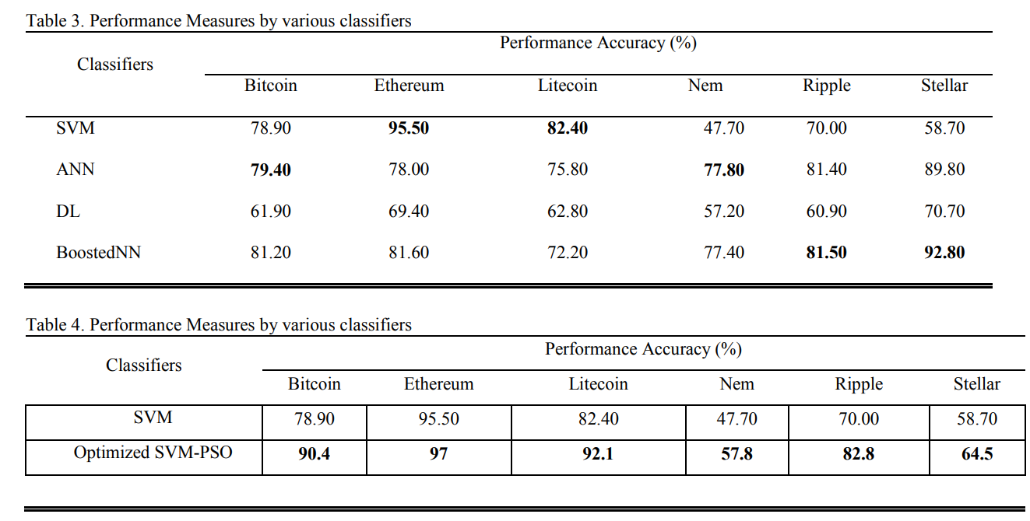

### Deep Learning-based Cryptocurrency Price Prediction

In this paper, the researchers apply a hybrid Long short-term memory (LSTM) and Gated Recurrent Unit (GRU) model to 2 cryptocurrencies (Litecoin and Monero) to predict their price [9].

These researchers are creating a new model that has not been tested before. They give a breakdown of all the methods used and their corresponding accuracy as well as the year it was created.

They collected their daily data and then performed data pre-processing. The data they used was ranged from August 2016 – February 2020 for Litecoin (1279 data points) and January 2015 – February 2020 for Monero (1851 data points). After performing data pre-processing, the researchers split their data into testing and training. An image of their proposed model is shown in [Fig. **4**], they combine 2 LSTM models with a single GRU model to get a price prediction.

The researchers used quantitative methods to test their designed algorithm. They also compared their model to the standard LSTM model and provided a graph of this comparison. They tested the algorithms across different windows (1-day, 3-day and 7-day prediction) and created a table to breakdown their results. Quantitative methods are more appropriate for this paper because the researchers needed to know how accurate their method is in terms of numbers so they’re easily able to compare this to other models that are available.

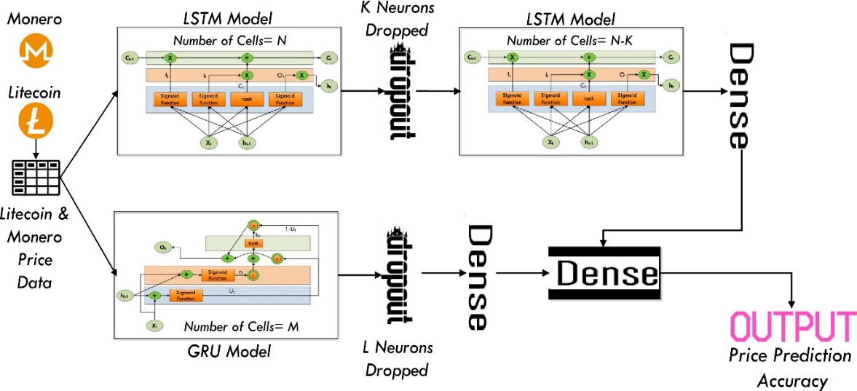

Fig 4 – Proposed model from [9]

The researchers compared the accuracy of their model to other models available. They collected a variety of accuracy variables, such as: Mean Squared Error, Root Mean Squared Error, Mean Absolute Error and Mean Absolute Percentage Error (MSE, RMSE, MAE and MAPE) to evaluate their algorithm. They then used graphs to plot these error values to compare the standard LSTM model with their hybrid model. Their error values proved to be a lot lower than the other model they were comparing against which supports their findings. They concluded with “Our proposed scheme has proved to be better than the LSTM network, which is evident from the errors of prediction.” But they also stated that there were a large number of challenges for future researchers to delve deeper into.

### Stochastic Neural Networks for Cryptocurrency Price Prediction

In 2020, researchers published a paper exploring price prediction for cryptocurrency using stochastic neural networks[10]. These researchers used a stochastic multi-layer perceptron and long short-term memory (LSTM) which is like 2.2.2 where they used an LSTM model when predicting Litecoin and Monero.

These researchers took a variety of different data when compiling their models. Including the daily low, high and trading volume. Along with social sentiment information such as google trends and tweet volumes. They then used 850 data points from 2017 to 2019 to help train their model. After collecting their data, they computed data pre-processing to normalise all their data. An image of their model can be found in [Fig.5].

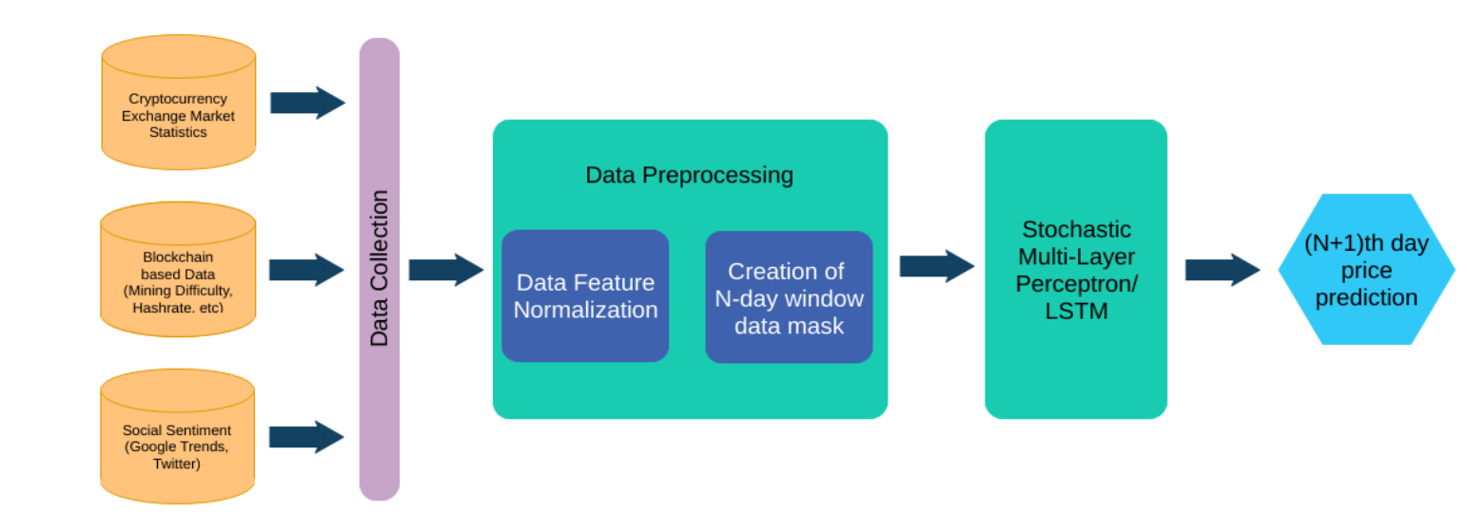

Fig 5 –model from [10]

After collecting their results, the researchers used a variety of evaluation metrics, similar to 2.2.2 which was an effective way to see if their model was accurate or not. The Mean Absolute Percentage Error (MAPE), Mean Absolute Error (MAE), Root Mean Squared Error (RMSE), and Mean Squared Error (MSE) were used. Their results showed that stochastic neural networks were slightly better than deterministic models.

This was a very effective paper that provided a lot of insight as to how to go about comparing a variety of different models. There are a lot of strengths in this paper that I have been able to take on board when it comes to evaluating my own dataset.

### The Recurrent Reinforcement Learning Crypto Agent

Researchers from University College London used a recurrent reinforcement agent to trade bitcoin VS USD on a perpetual swap contract [11]. This was done over a period of 5 years and the agent returned a total of 350% profit.

The researchers used transfer learning, an echo state network and a target model using the Sharpe ratio to train their reinforcement agent to learn to trade digital assets using futures.

Futures trading is where you either short (predict that the price of the asset will go down) or long (predict that the price will increase over time).

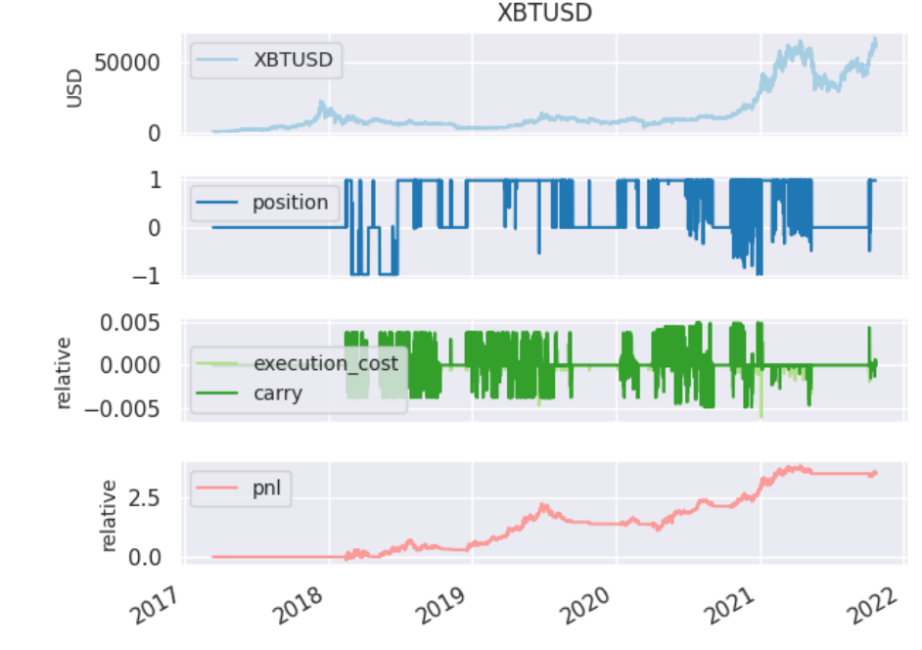

Fig 6 –results from [11]

Looking at [Fig 6] you can see how well the agent performed. Something that I really like about this paper is in contrast to the rest of the research I have seen previously. Highlighted by the blue square is the profit that the agent gained towards the middle of 2019. This agent performed exceptionally well during the bear market which is very impressive that it was able to predict bitcoin to stay low and gain massive amounts of profit. This is in contrast to other research available as most have been unsuccessful in predicting the price to fall.

### Cryptocurrency Trading Using Machine Learning

Thomas E. Koker and Dimitrios Koutmos went about researching cryptocurrency trading using a reinforcement-based machine learning approach [12]. For this, they traded the top 5 crypto coins at the time (Bitcoin, Ethereum, Litecoin, Ripple and Monero) and compared their model with a buy and hold approach.

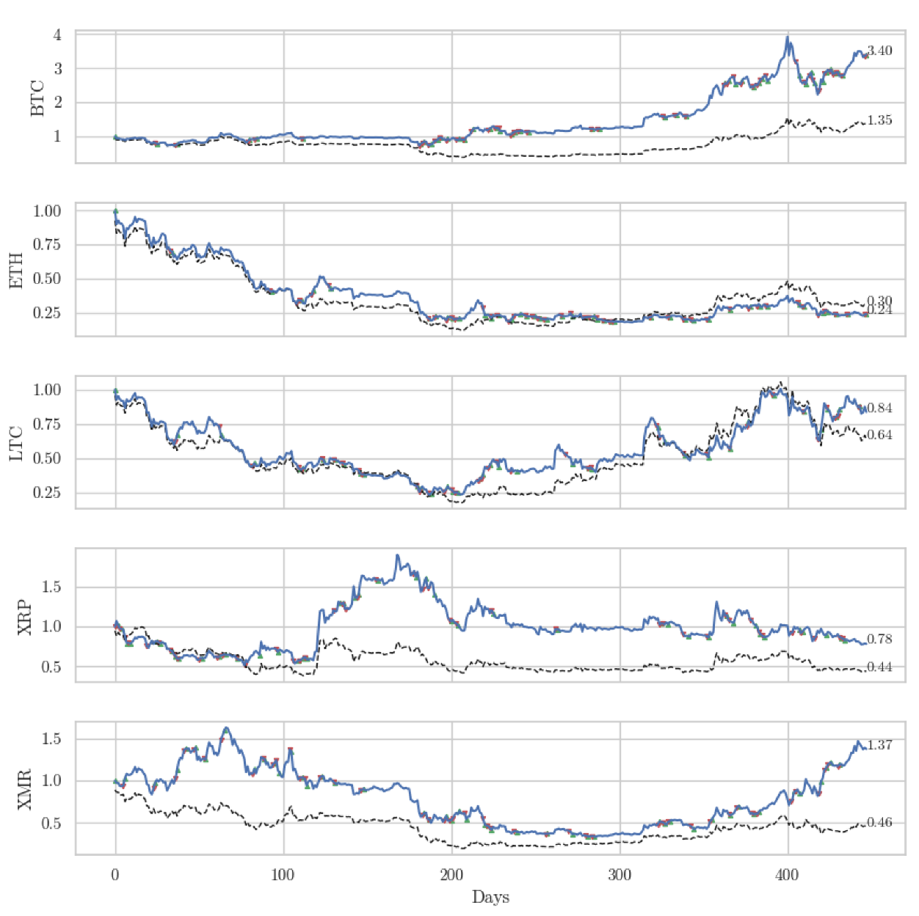Thomas and Dimitrios trained their model for 1000 days and then simulated trading for a further 100 days before letting their model trade for 447 days. Their model is based off of the buy-and-hold trading method but similar to 2.2.4 they used the Sharpe ratio to calculate the risk of returns.

Fig 7 –results from [12]

The results from this can be found in [Fig. 7] and they found that their model (blue line) significantly outperformed the buy-and-hold strategy (black line). Whilst this paper is an interesting read, I was hoping that the researchers would give some comparisons to other machine learning methods. The researcher’s paper isn’t very in depth, but it provides some good insights as to how their model compares with the buy-and-hold strategy. I would have been more insightful if they had better metrics for comparing their model.

### Using machine learning for cryptocurrency trading

Jifeng Sun, Yi Zhou and Jianwu Lin used random forest to predict a variety of cryptocurrencies’ prices [13]. These researchers compared a variety of different market data. Using 10 second intervals and 10-minute intervals for their data points.

They found that 10-minute intervals were more effective than the 10 second data.

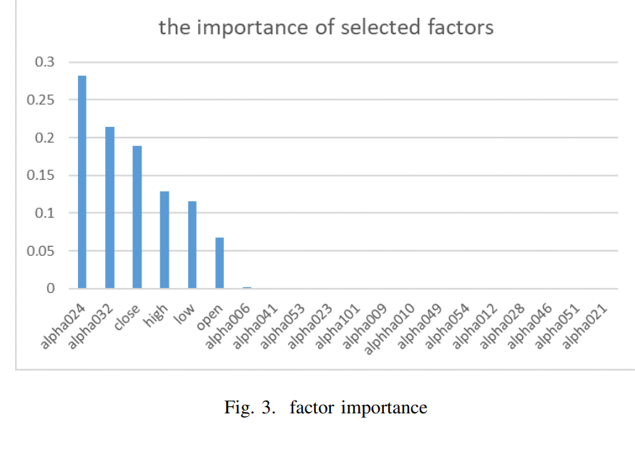

Fig 8 –Factor importance [13]

[Fig 8] shows the importance of the factors used in the researchers’ machine learning models. They found that the close, high, low and open data proved to be very important. This is useful for my research because my models will be using this data as an input into the machine learning methods that I will be testing.

This paper provided some interesting research into random forests and price prediction. The accuracy of their models reached 58% which is why I chose not to include decision trees as part of my machine learning models. However, this paper does a good job at showing which factors are important for the machine learning models.

### Is smarter better? : a comparison of adaptive and simple moving average trading strategies

In 2005, Craig A.EllisSimon and A.Parbery researched the moving average strategy and compared this to buying and holding 3 stocks in the stock market [14]. They compared the adaptive moving average (AMA), simple moving average (SMA) and the Buy and hold method.

Fig 9 –Results [14]

[Fig 9] shows the results of the experiment. Throughout the research the moving average strategies outperformed the buy and hold strategy in terms of gross return. However, the moving average strategy is dependent on the market fluctuating because if the market was just to rise in price then the buy and hold strategy is more effective.

This paper shows how impactful the moving average strategy is. However, this paper was made in 2005 and the moving average strategy is under-researched, especially in more recent years. The researchers did a good job at displaying their results, but in the years that they carried out their tests the market was constantly on the rise which may invalidate some of their results.

### Prediction of cryptocurrency returns using machine learning

Researchers used a variety of machine learning techniques to analyse the top 12 most liquid cryptocurrencies. For this experiment, they used market data along with technical indicators as model features. The researchers used data from 2017-2018 to train their models. Similar to my project, the researchers have used the relative strength index and a variation of the moving average.

Fig 10 –Results [15]

[Fig 10] shows the average results from all 4 machine learning algorithms tested by the researchers. From the table we can see that the machine learning algorithms are more effective at the daily predictions rather than 15-minute intervals.

This paper did a really good job at explaining how all the machine learning methods were implemented. Furthermore, the researchers carried out a lot of different tests on a large range of cryptocurrencies especially in comparison to the rest of the papers that I have researched. The researchers also tested a wide range of machine learning models which gave me an insight as to which methods are better to use on this type of problem.

### Summary of what I’ve learnt from these papers

In summary, all the papers used quantitative methods to evaluate their algorithms. Most papers used accuracy as a measure of effectiveness for their algorithm. The papers show that the most effective way to evaluate a model is by using MSE, RMSE and MAE which is what I’ll be considering when evaluating my models. Looking at the papers, I can see that the better models were some variations of Support vector machines (SVM) and artificial neural networks (ANN).

From paper 2.2.6 I can see that decision trees are ineffective hence why I have not chosen to explore this model in my project.

|  |  |  |
| --- | --- | --- |
|  | Pros | Cons |
| ANNs | * Accurate at predicting regression. * Very flexible and can be applied to a large variety of problems. * If a few datapoints are missing the model can still provide accurate results. | * Many hyperparameters to set and test. * Very long training times. * Require many datapoints to create an accurate model. * Computationally expensive. * Might overfit on the training data used. |
| Regression Trees | * Easiest model to implement * Easy to visualise * O(depth) testing complexity | * Tends to overfit if pruning isn’t done correctly. * An exponential number of possible trees for each problem. |
| SVM | * Gaussian kernels allow for SVMs to excel in high dimensional scenarios. * Uses support vectors to create a margin which makes is computationally efficient for linear problems. * Good accuracy for regression problems | * Requires a good setting for the hyperparameters. * Struggles on larger data sets * Takes a longer time to train when computing regression problems. * SVMs are sensitive to noise. |

Fig 11 –Pros and cons table for machine learning methods

From these papers and other research, I can breakdown the machine learning methods with pros and cons [Fig 11]. This is useful for my project as I am now able to see which methods excel in certain areas and I will be able to apply this to my problem.

In terms of mathematical methods, this area seems to be under-researched as the only paper I was able to find was written in 2005. I will be taking their findings and applying them to the crypto market, and it will be interesting to see how the methods compare to machine learning methods.

## Existing Trading Bots

### Pionex

To see what the Pionex trading page [16] looks like please visit the appendix [Fig 1].

This trading bot has a very low fee of 0.05% per transaction which is low compared to the rest of the industry. As you can see from the figure, the page has a lot of potential bots that you can create to automatically trade a very large variety of cryptocurrency. Furthermore, there is a manual trading page that is useful for experienced traders who want to do this manually.

Whilst there is a large variety of bots available, there is only a small description as to how these work and their description is very vague. For example, “buy low and sell high” seems to just be setting values for the bot to buy and sell at, with very little intelligence at play.

So, for this bot page, there is very little intelligence being used and some of the bots seem quite complex to set up with little guidance.

### CoinRule

CoinRule is another trading bot that boasts a large variety of different trading techniques[17]. As you can see from appendix [fig 2] there are over 150 different trading strategies available for members. These methods are very in depth and explained exceptionally well. Some methods include the relative strength index (RSI) and the moving average (MA) which I will be taking advantage of in my project.

Their user interface is very friendly for beginners allowing If/then parameters to setup your bots. The premade templates are also useful for people who are unsure on how to start.

Whilst this bot is very well made, the barriers to entry are high. The free account only allows a few premade strategies, a small number of bots and a small amount of trading volume. Upgrading to the highest tier will set you back over £400 a month.

### TradeSanta

TradeSanta is another popular crypto trading platform used by lots of people [18]. Looking at appendix [Fig 3] you can see what the home page of the trading bot page looks like. Something good about TradeSanta is that they have a tutorial which is very useful for new users. Furthermore, they also have a virtual trading bot which lets you experiment with fake money first before staking your own cash.

Their technical indicators also utilise the RSI and MA strategy along with a few other strategies, but a lot less compared to the other trading bots available.

### Cryptohopper

Cryptohopper is the last trading bot platform that I will be looking at [19]. There are a lot more out there, but these are just the most popular bots that I have found amongst the community. Cryptohopper is the only trading bot that states they use AI to automate their trading.

Appendix [Fig4] shows the landing page of cryptohopper. When first logging in you are greeted with a tutorial that takes you through all of the different tabs and documentation that will guide you. If creating a free account, you are very limited in terms of bots you can setup. There are only a few strategies available.

They only allow you to use the AI-powered strategy if you sign up to their most expensive monthly subscription. So, I am unsure as to what AI method they are using to back test their bots.

### Summary of what I’ve learnt from these trading bots

From these trading bots I have learnt a lot of useful information with regards to different trading strategies and user interface available to the users of the platform. It seems like a lot of these platforms offer a wide range of strategies and ease of use when setting up the bots.

However, most of the platforms require payment to get the most out of their bots. The free tiers offer very little for consumers with minimal strategies and volume limitations.

Taking these details into account when looking at my project, I will be trying to implement a user-friendly interface that isn’t confusing for beginners. Furthermore, I have seen a large variety of mathematical trading indicators that I had previously researched. This backs up my research and I will be using the RSI and MA methods when implementing my mathematical trading strategies.

These methods seem to be well known in the community and very popular. So comparing these methods to machine learning strategies will be a good indication as to how they perform.

# Design and Implementation



## Software Design

In this section I will talk about the different software choices that I have made to make the program easier to follow and understand.

### Graphical User Interface

The program consists of a home page that lets the user switch between the time periods that I have programmed (2018-2021, 2021-2022, Live) Once they have chosen their desired time frame there are options for each specific bot that they are able to open. This will load a new page which will display some different details.

Looking at figure 12 you can see what the home page looks like. This shows clearly how the user should interact with the program, there is a clear dropdown box that allows the user to change the time period. Furthermore, I have colour coded the buttons so that purple indicates the machine learning techniques and red indicates the mathematical techniques.

Fig 12 – Program home page

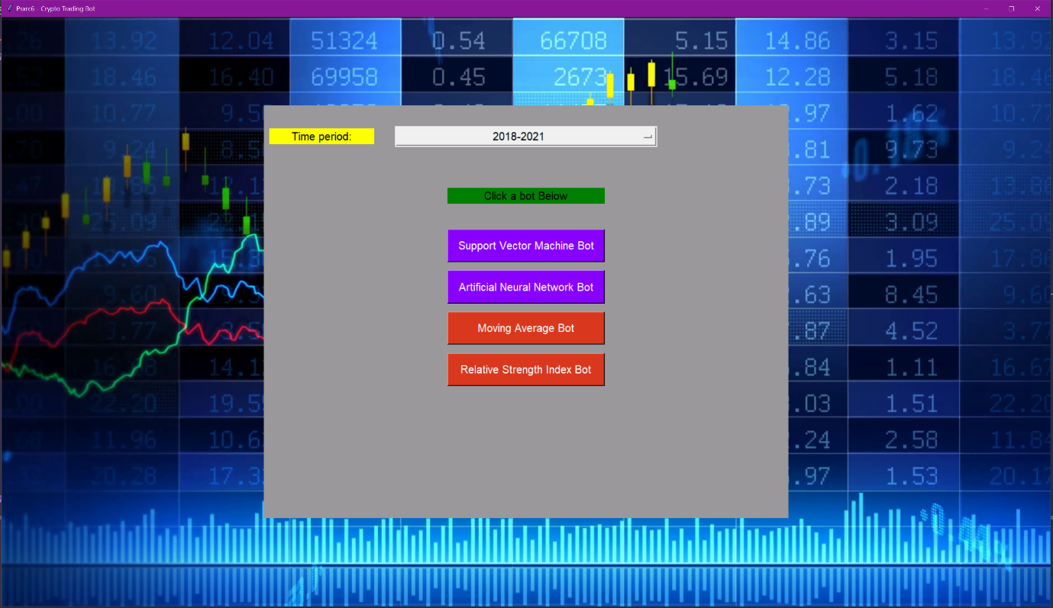

Figure 13 shows an example of the bot page. The top is a navigation bar that lets the user go back to the home page, change the coin they wish to test using a dropdown or begin trading with the green button in the tope right. The left-hand side is a graph of the training data, this lets the user see what data was used to train the trading bot. The right-hand side is the test data graph and then the bot’s predictions over the top of the test data. The bottom of the screen displays details of how the bot is trading.

This design is super simple and effective, it displays all the necessary details needed to understand what is happening and also lets the user clearly see the bot’s predictions.

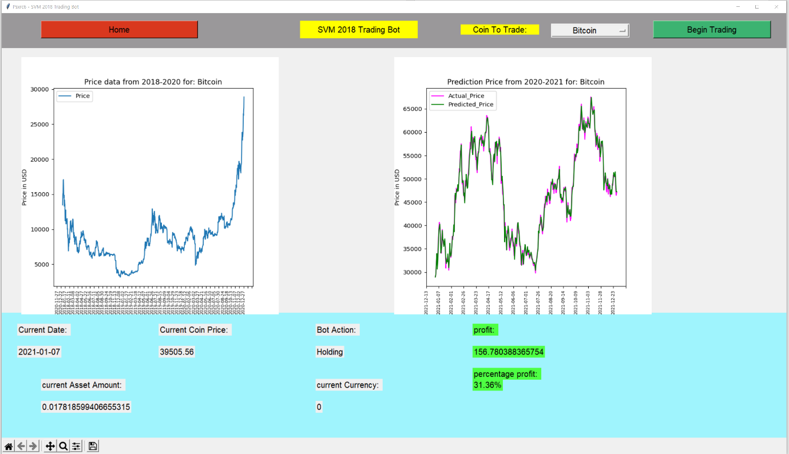

Fig 13 – Bot trading page

### API utilisation

To collect data about each coin and its market history, an API was used. This allowed me to collect large amounts of data efficiently and effectively.

I was able to manipulate the data and store it into an excel file so that when the program was run it wasn’t always calling the API for the same data. However, the live bots call an API request every time they are run as the dates will change. Also for the live data, code was used to calculate the closest time to the next datapoint so that no errors were created when creating the API request [Fig14].

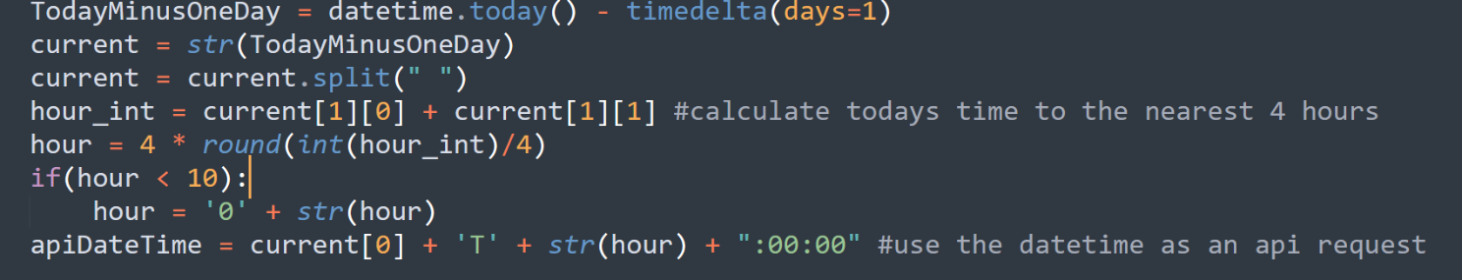

Fig 14 – Date code

Combine all the variables to get a string API request

Round the hour to the nearest 4 as this is what the data point intervals were

Appendix [Fig 5] shows the code used to retrieve the data. This uses a nested for loop as the API returned a dictionary of rows and then each row was an array that had to be looped through and entered in to an excel file. I also split the date entries because there were unnecessary timestamps added to the datapoints.

When handling the data, I had to normalise the numerical values using a standard scalar, this allowed the machine learning techniques to learn more effectively. I also had to strip the dates when using test data as this was not possible for the machine learning techniques to process.

## Machine Learning Strategies

In this section I will talk about the different machine learning strategies I’ve implemented in my project. I will cover the basics as to how they work and also talk about how they work within my program.

### Support Vector Machines

Support Vector Machines (SVM) are a type of supervised machine learning technique effective for both classification and regression.

In classification SVMs use a decision boundary (hyperplane) and takes some points as support vectors to work out whether a new point would belong to class A or class B. Looking at [fig 15]you can see how this works. There’s a decision boundary and a margin for either side of the classes. Any point that falls inside that margin will be come a support vector to ensure that new points are not misclassified.

The classification in [figure 15] is an example of a linearly separable dataset.

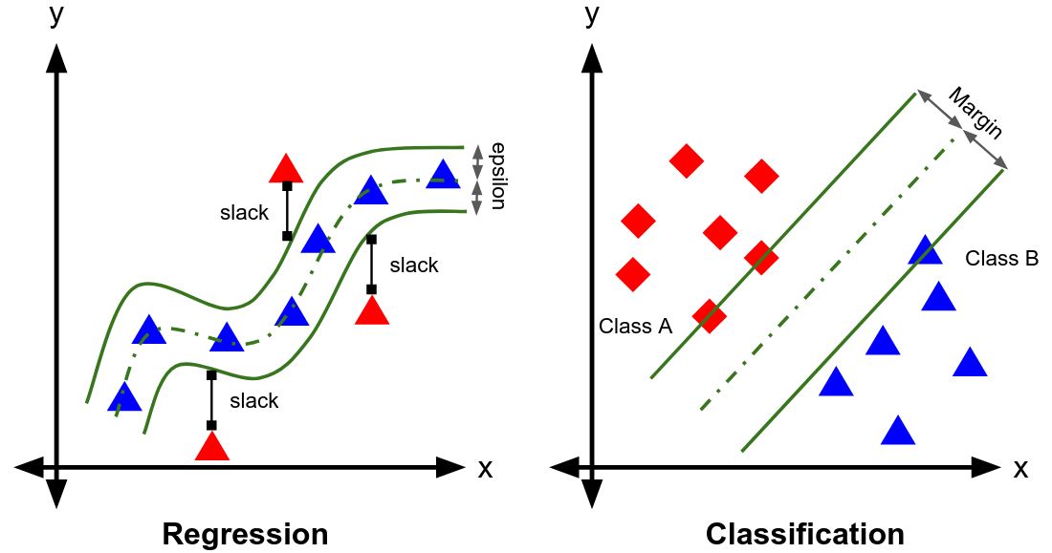

Fig 15-regression and classificationfrom[20]

In my project, the dataset consists of 5 features: 'price_open', 'price_high', 'price_low', 'volume_traded', 'trades_count' representing this on a graph becomes very difficult. With support vector machines, a kernel trick can be used to transform the data into a higher dimension making the support vector machine perform better and allows us to map the data as linearly separable. In this project I have used the gaussian kernel (also known as the RBF kernel) to transform my feature set into a higher dimension.

When creating an SVM machine there are a variety of parameters that can be set. C is known as the box constraint, which is the slack variable that controls the decision boundary. A larger value of C will use a smaller hyperplane (or margin) which proves to be very good for the data that I am using. A larger value significantly outperforms the smaller value of C [fig 16].

Fig 16 – Left C of 1, Right C of 1e4

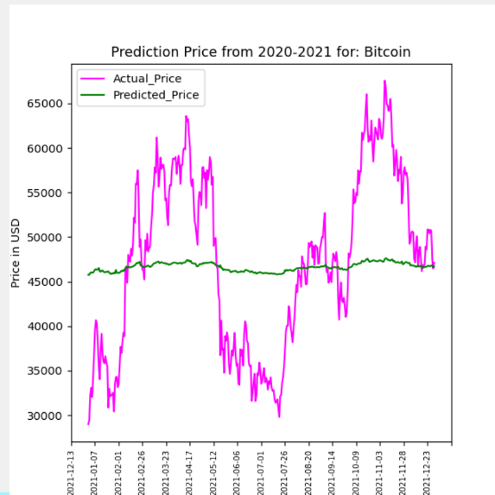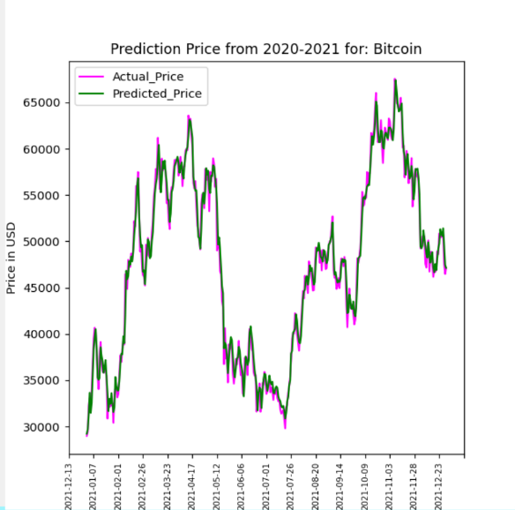

Epsilon (also known as gamma) signifies the width of the decision boundary, the larger the value of epsilon, the larger the decision boundary will be. A larger decision boundary will result in less support vectors being used by the SVM. However, this also causes a lower accuracy for the model, the smaller the value of Epsilon the better the model will perform, but it will also increase computation time. This can be seen in [figure 17], the lower value of epsilon massively outperforms the higher value of epsilon.

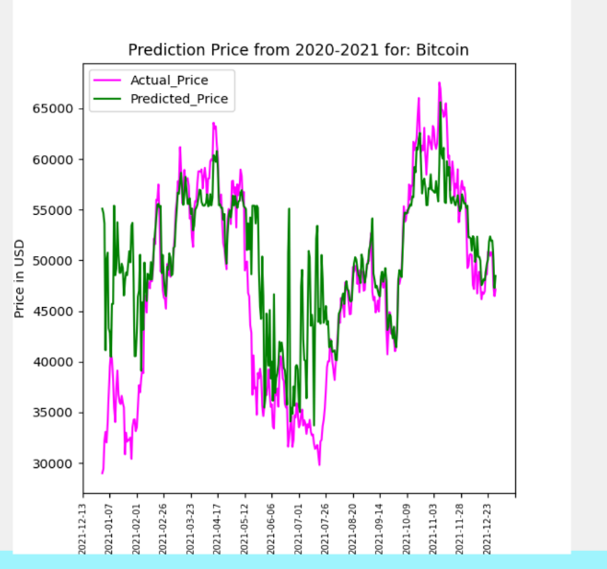

Fig 17 – Left Epsilon of 2, Right Epsilon of 0.0001

If I had more time I would have performed K-fold cross validation to tune the hyper parameters. Nested cross validation is needed to optimize the accuracy of the model. The outer loop of nested cross validation is used to estimate the generalization error (or overall accuracy of the model). The inner loop in cross validation is used in selecting and optimizing the hyper parameters. However, the default values used for my SVM returned a very high accuracy and therefore I didn’t feel the need to tune the hyperparameters.

### Artificial Neural Networks

Artificial Neural Networks (ANN) are a type of deep learning algorithm. The way they work is modelled after a human brain, with neurons sending signals to each other.

A neural network is composed of an input layer, some series of hidden layers and then an output layer [fig 18].

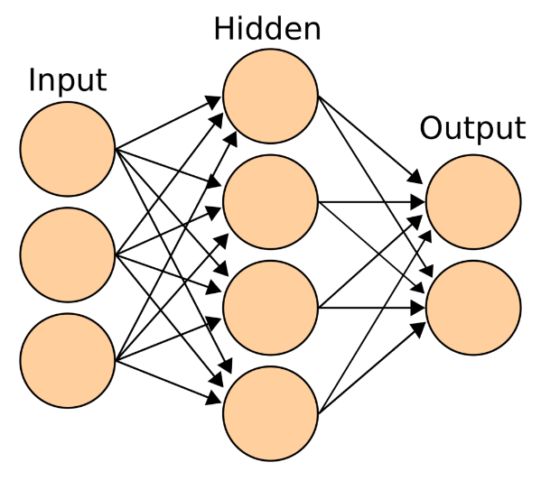

Fig 18 – representation of a neural network

This is a simple example of how a neural network can be modelled. The input layer is a 1:1 ratio with the number of features in the problem with an additional node acting as a bias. The input layer passes data to the hidden layer in a fully connected way. The data that is passed can be represented by an equation:

aj = Σ wji xi + wj0

i=1

D

Where aj is the is the activation at new node j. D is the number of nodes in the layer, ji is the path between node i and node j. W is the weight being passed and Wj0 is the bias weight added onto the activation.

The hidden layer performs a type of activation function (set in the code) that either links to another hidden layer or links to the output nodes. In my program I have chosen to use a rectified linear unit (RELU) activation which uses the equation:

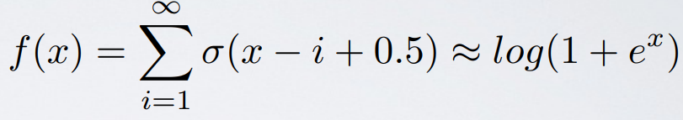

This equation is fairly new and solves the vanishing gradient problem. This is when multiple layers are added, and the gradient becomes so small that it is very hard to train the model and get an accurate prediction.

The output node is just a single node for my regression problem that in my case will be an estimate of a coin price on a given date time, this is also referred to as Ŷ.

The goal of a neural network is to minimise the cost function (also known as loss), the network goes through using backpropagation or feedforward techniques to adjust the weights and biases of the network’s layers to reach a point of convergence where the cost is at its lowest point.

An optimiser is used to adjust the weights, some are more aggressive than others with weight adjustment. Being too aggressive can lead to overshooting the local minimum, but not adjusting the weights enough can lead to a very long process of getting to the local minimum.

Fig 19 – my program’s neural network

When creating my program I tested a lot of different options regarding optimisers, loss functions and layer sizes. As I was limited for time, I was not able to thoroughly test the options available but [Fig 19] shows how I have modelled my neural network.

When doing my research, I was able to find that the LSTM (long short-term memory) was the most effective layer to add. One of many sources stated [21] “Long Short-Term Memory Network or LSTM, is a variation of a recurrent neural network (RNN) that is quite effective in predicting the long sequences of data like sentences and stock prices over a period of time.”

The dense layer acts as the output layer, so my neural network only consists of one set of 128 nodes as a hidden layer. I found that this gave the best performance, because when connecting multiple layers in succession I found that the accuracy of the model decreased, and training time doubled [Fig 20].

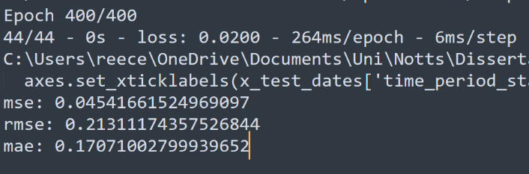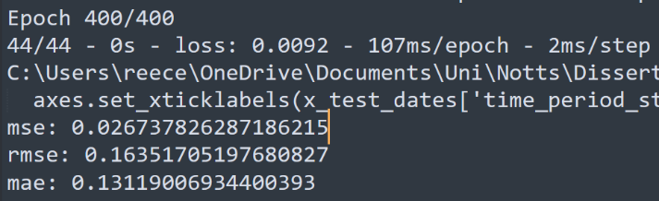

Fig 20 – left multiple hidden layers, right one hidden layer

The loss chosen was mean squared error, as this gave the best result across all the loss functions when optimising. When choosing an optimiser, the adamax was chosen, this is a similar optimisation function to the adam optimiser however, the adamax optimiser is more robust to noise and as crypto price data is quite noisy adamax is the better choice and yields better results.

## Mathematical Strategies

In this section I will be discussing the mathematical techniques implemented in my program. This section will describe how they work in general and then the application of the strategy within my program.

### Moving Average

The moving average strategy is a popular mathematical technique used amongst traders. There are many different types of moving averages that are calculated in different ways.

### Relative Strength Index

# Results and Discussion



## Machine Learning Results

Sensitive to rapid changes in price

## Mathematical Results

## Combined Evaluation

## Did I meet my Aims/Objectives?

# Critical Appraisal



## What went well

## What went badly

## What I would have done differently

## Future Development

# Conclusion

# References

[1] Lamport, L. (1994). LATEX : A document preparation system (Second ed.). Addison-Wesley.

[2] PrimeXBT Editorial Team “Cryptocurrency Trading Strategies: Learn to Profit From Bitcoin, Ethereum, and More”. April 13, 2021. Last visited 09/06/2022. Found at: <https://primexbt.com/for-traders/cryptocurrency-trading-strategies/>

[3] Evan Jones – CryptoVantage “A Brief History of Cryptocurrency” June 17 2022 Last Visited: 13/06/2022. Found at: <https://www.cryptovantage.com/guides/a-brief-history-of-cryptocurrency/>

[4] Scott Chipolina “Why do Altcoins Usually Follow Bitcoin?” Decrypt. Sep 2020. Last Visited 17/06/2022. Found at: <https://decrypt.co/42834/why-do-altcoins-usually-follow-bitcoin>

[6] CoinAPI.io “Market Data - Starter Guide” 2022. Last visited: 28/07/2022 Found at: https://docs.coinapi.io/?python#historical-data-get

[7] Reece Cripps “COMP4037 Research Methods Coursework 3 – Computer Science in Cryptocurrency” April 2022.

[8] Hitam, N.A., Ismail, A.R. and Saeed, F., 2019. “An optimized support vector machine (SVM) based on particle swarm optimization (PSO) for cryptocurrency forecasting.” Procedia Computer Science, 163, pp.427-433.

[9] Patel, M.M., Tanwar, S., Gupta, R. and Kumar, N., 2020. “A deep learning-based cryptocurrency price prediction scheme for financial institutions.” Journal of information security and applications, 55, p.102583.

[10] P. Jay, V. Kalariya, P. Parmar, S. Tanwar, N. Kumar and M. Alazab, "Stochastic Neural Networks for Cryptocurrency Price Prediction," in IEEE Access, vol. 8, pp. 82804-82818, 2020

[11] Borrageiro, G., Firoozye, N. and Barucca, P., 2022. “The Recurrent Reinforcement Learning Crypto Agent” (pp1- 19).

[12] Koker, T.E.; Koutmos, D. Cryptocurrency Trading Using Machine Learning. J. Risk Financial Manag. 2020, 13, 178.

[13] J. Sun, Y. Zhou and J. Lin, "Using machine learning for cryptocurrency trading," 2019 IEEE International Conference on Industrial Cyber Physical Systems (ICPS), 2019, pp. 647-652.

[14] Ellis, C.A. and Parbery, S.A., 2005. Is smarter better? A comparison of adaptive, and simple moving average trading strategies. Research in International Business and Finance, 19(3), pp.399-411.

[15] Akyildirim, E., Goncu, A. and Sensoy, A., 2021. Prediction of cryptocurrency returns using machine learning. Annals of Operations Research, 297(1), pp.3-36.

[16] Pionex trading bots Last visited: 01/07/2022 Found at: <https://www.pionex.com/en-US/>

[17] CoinRule trading bot Last visited: 01/07/2022 Found at: <https://coinrule.com/>

[18] TradeSanta trading bot Last visited: 02/07/2022 Found at: <https://tradesanta.com/en>

[19] cryptohopper bot Last visited: 02/07/2022 Found at: <https://www.cryptohopper.com/>

[20] Support Vector Regression – Beny Maulana (2019) - Last visited: 15/07/2022 Found at: <https://medium.com/it-paragon/support-vector-machine-regression-cf65348b6345>

[21] Keras LSTM Layer Explained for Beginners with Example – Palash Sharma – Feb 2021 – Last visited: 18/07/2022 - Found at: <https://machinelearningknowledge.ai/keras-lstm-layer-explained-for-beginners>

# Appendix A: Supplementary Materials I

Appendix Figure 1 - Pionex Trading bot page

Figure 2 – CoinRule Available strategies

Figure 3 – TradeSanta Bot Home page

Figure 4 – CryptoHopper Bot home page

Figure 5 – 2018 data reading (Code)

